1. You’re fetching a document with a lot of key-value pairs but you want some of them. Of course you can fetch all and then manipulate the data but still you’re transferring it over to the wire. So, you would kind of impact your bandwidth. So, it’s better to filter that out in the mongodb server and this is exactly what projection can help you with. 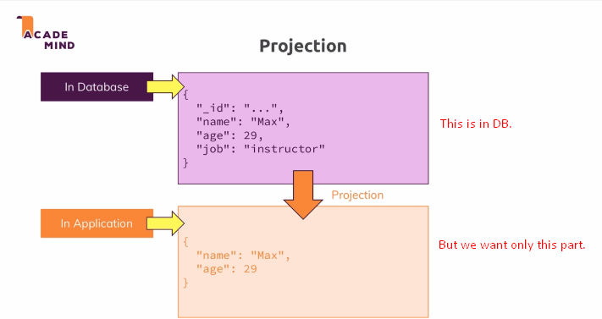
2. 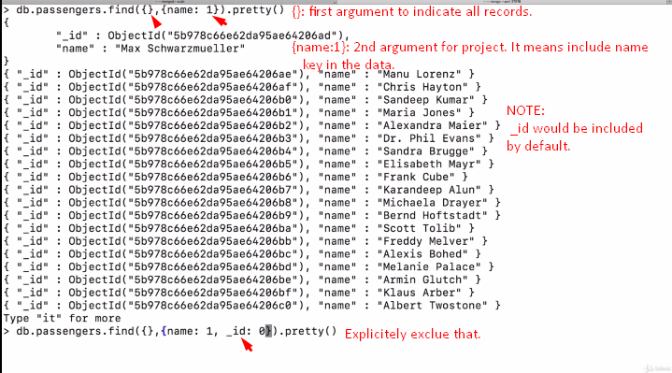
3. 